JAVA NOTES

Java is case-sensitive: "MyClass" and "myclass" has different meaning.

The name of the java file **must match** the class name.

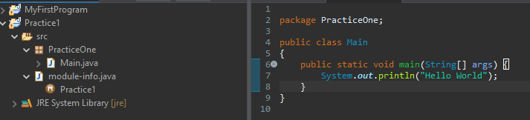

 every Java program has a class name which must match the filename, and that every program must contain the main() method.

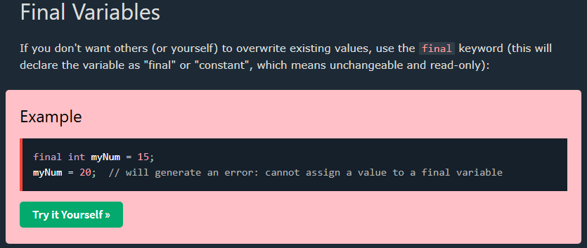

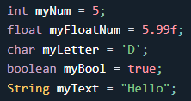

f : Explicity tells to the compailer that must be treated as float

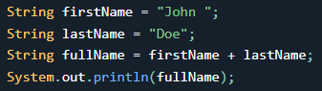

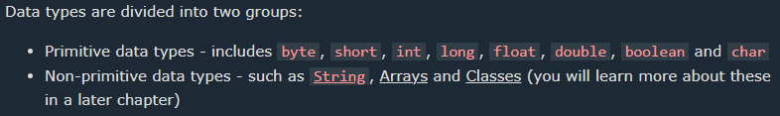

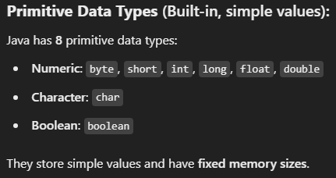

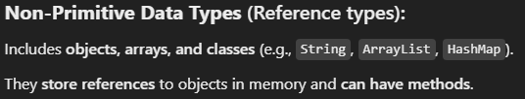

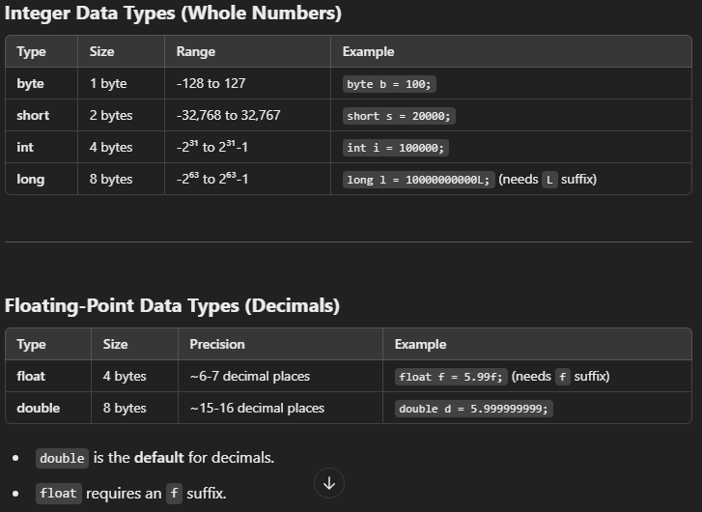

Indicates the number that can represent, for example “byte” 2^7 = 127 o 0 1111111 (representando el cero como el signo positivo)

U 1 1111111 = -128 donde 1 es igual a el signo menos

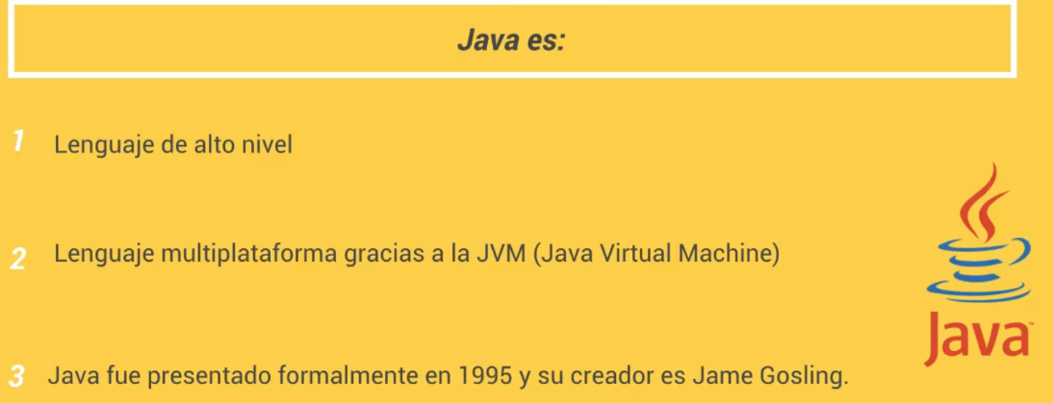

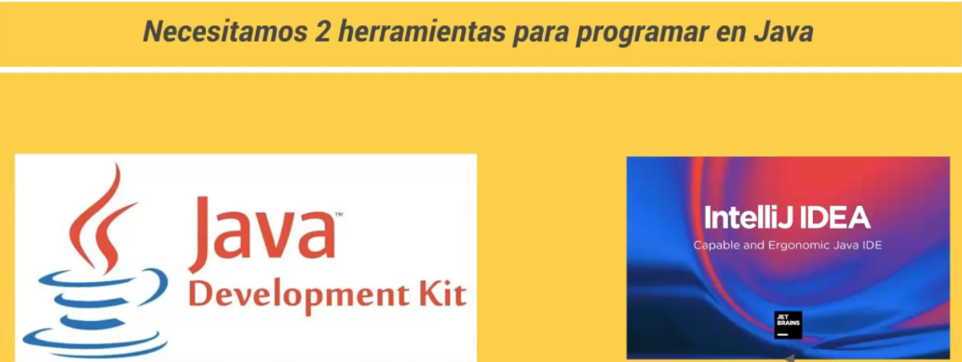

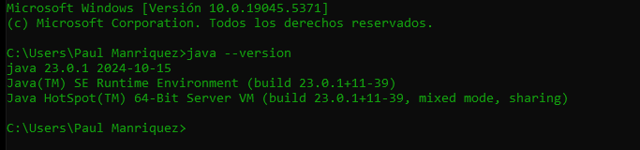

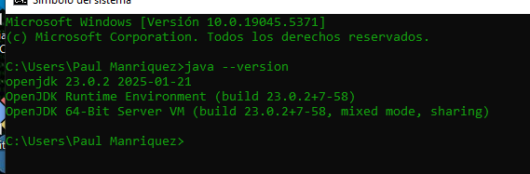

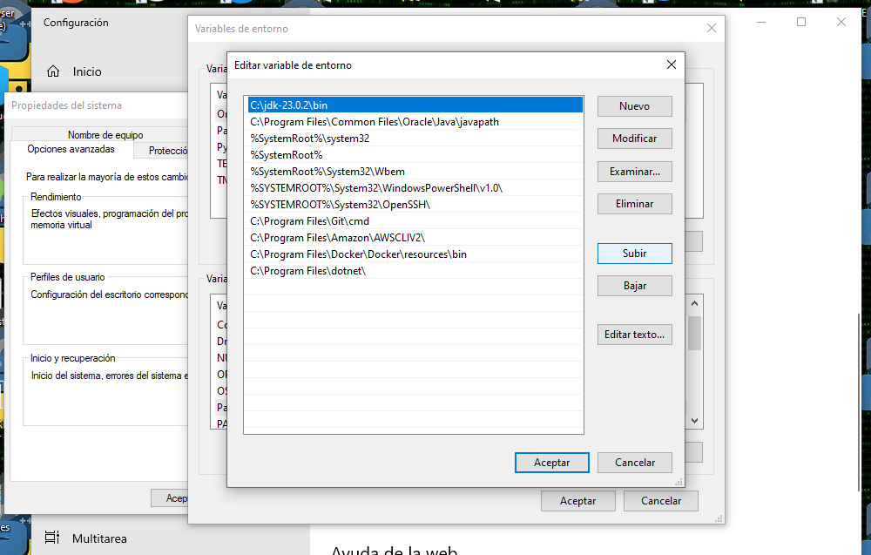

To set as your first reference jdk in the system,just up to the top most the path for the bin file

Compilation of a java class from the cmd on windows

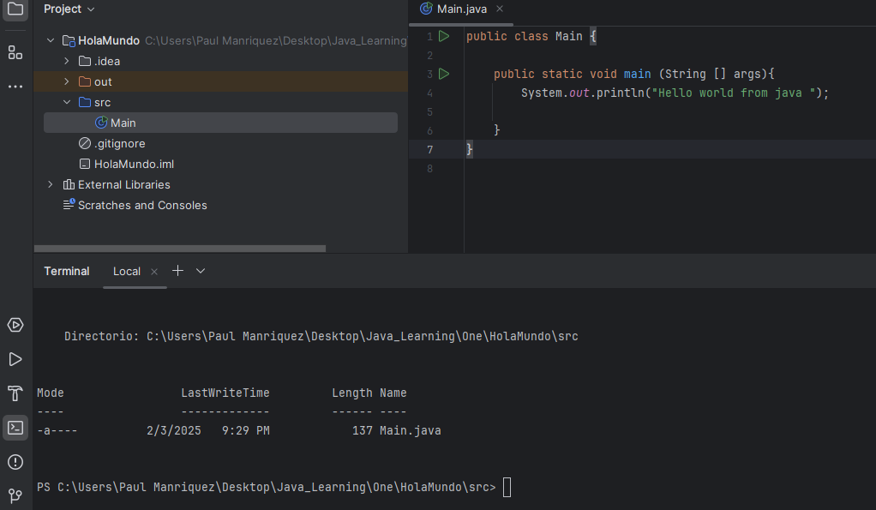

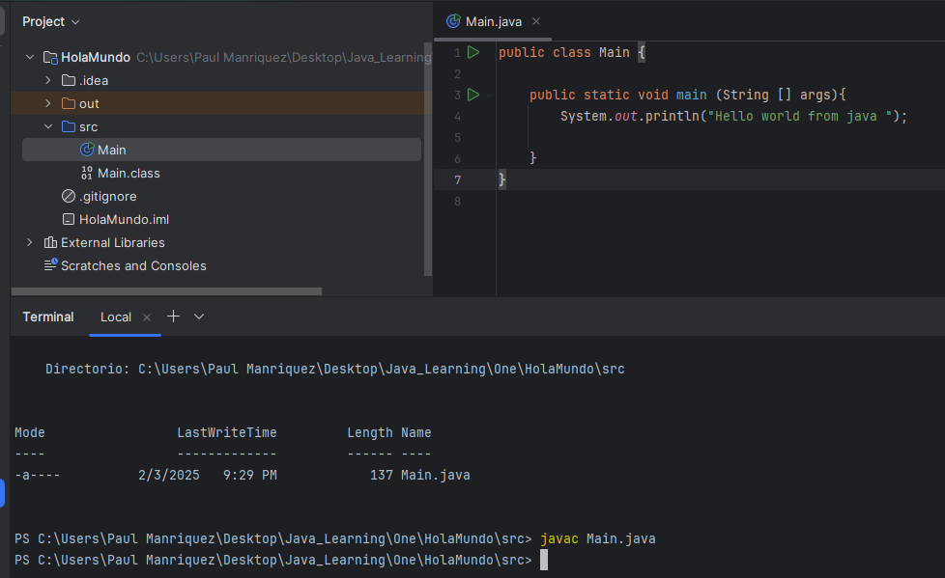

Javac : compile to enable to use it as an .exe file

Java Main: run the program class since it can now be executable

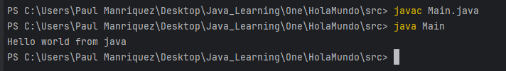

 Modifier of access, it means that it can be access from anywhere

 doesn’t need to be reference as an object to be able to be executed

 return type of the method

 name of the method and what received the method (to be able to receive strings from the keyboard)

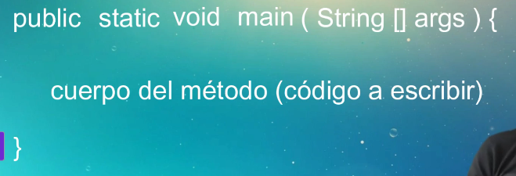

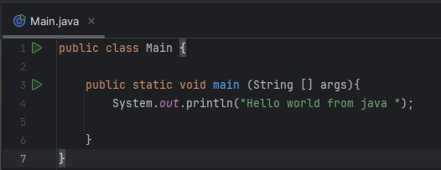

Video 11

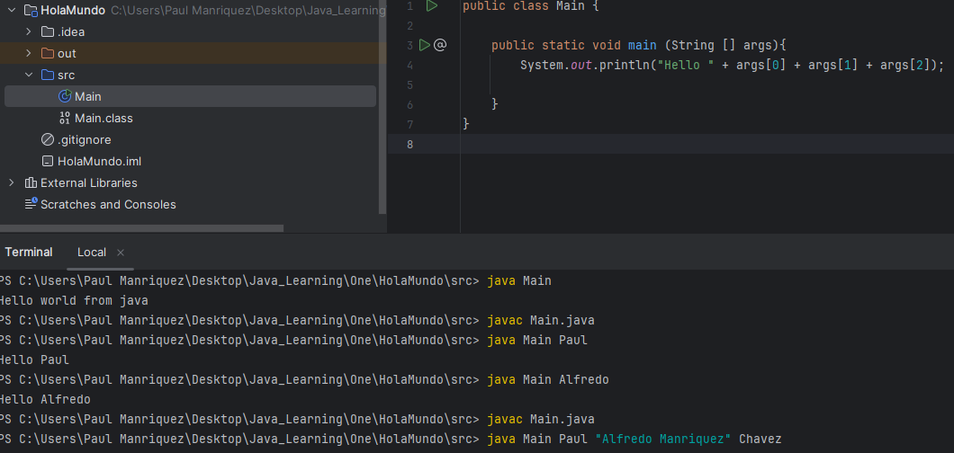

Compile

Execute and arguments

¿Que archivo se genera cuando se compila una clase java? Ans .class file

Day 2

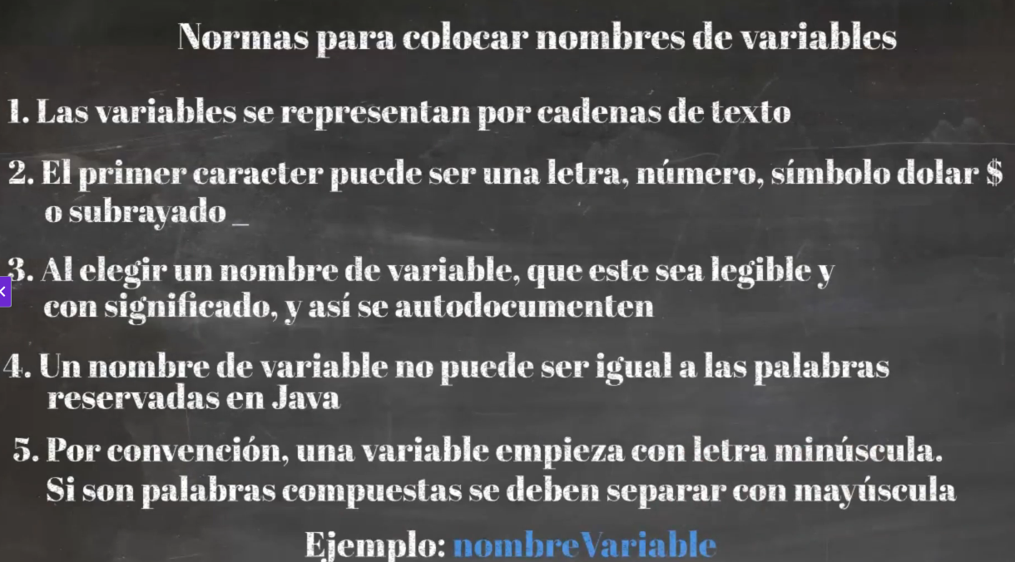

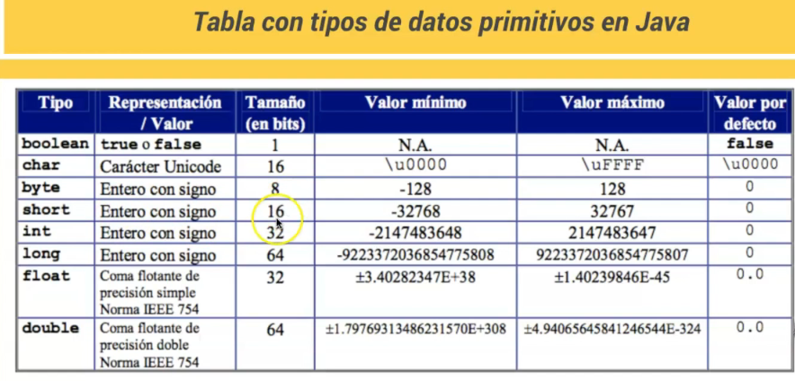

**Unicode** and Java

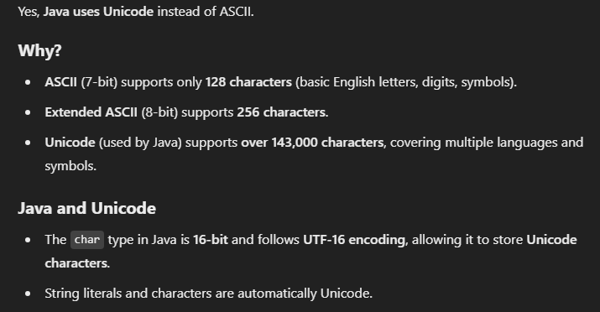

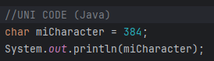

Offset

 char var1 = ‘a’ + 4

**Unicode Table PDF**

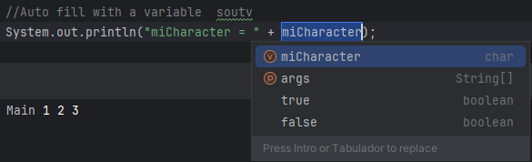

Tipo de dato y clase

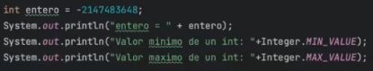

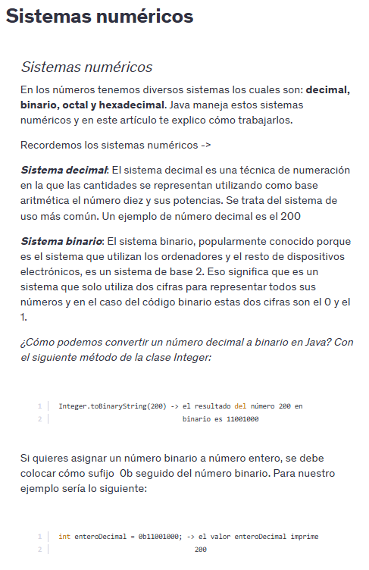

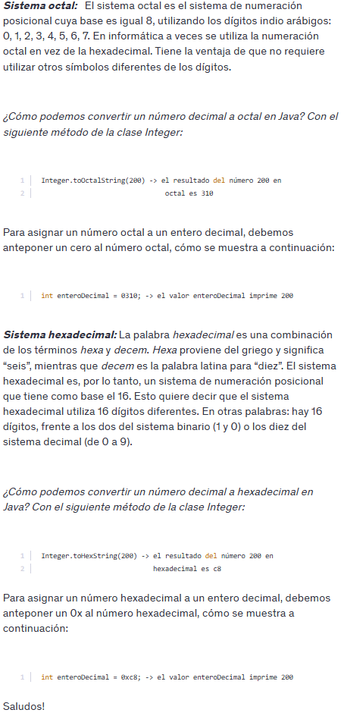

Parse

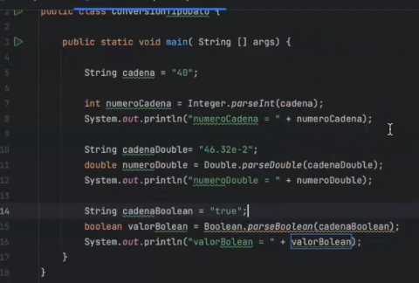

Number to string

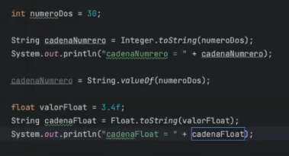

Dia 3

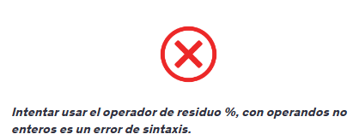

Returning a Boolean value

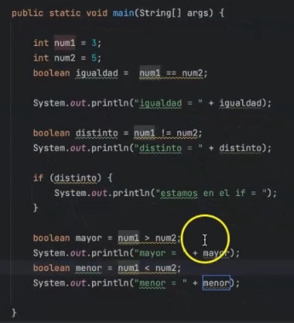

Postincremento y preincremento

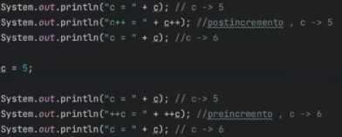

Decremento

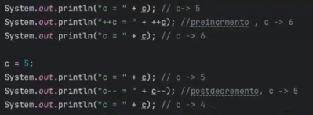

Operadores logicos

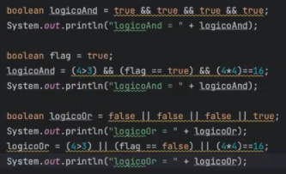



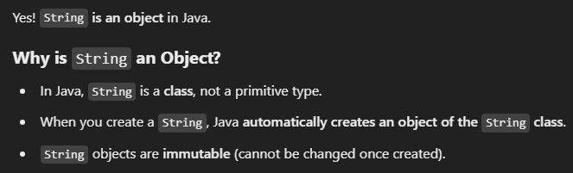

Day 4

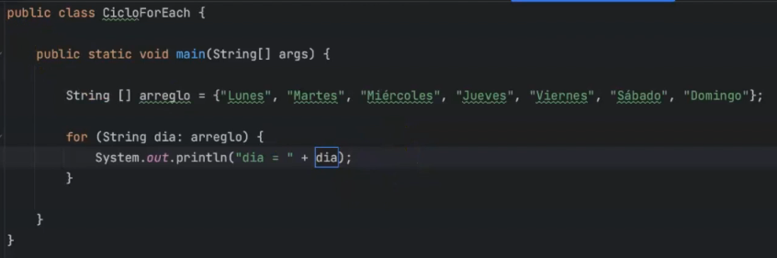

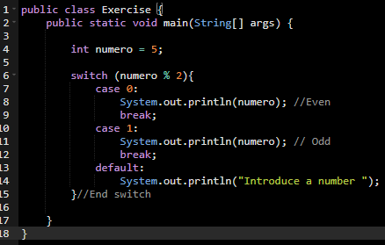

**Continue**

This keyboard pass all the code that is ahead of the it, in this case when i equals to 3 , pass all the code ahead and returns to the top

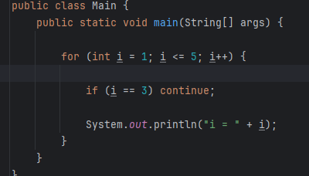 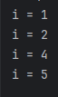

Dia 5

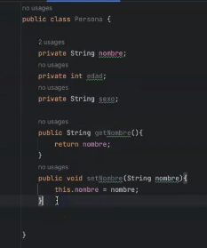

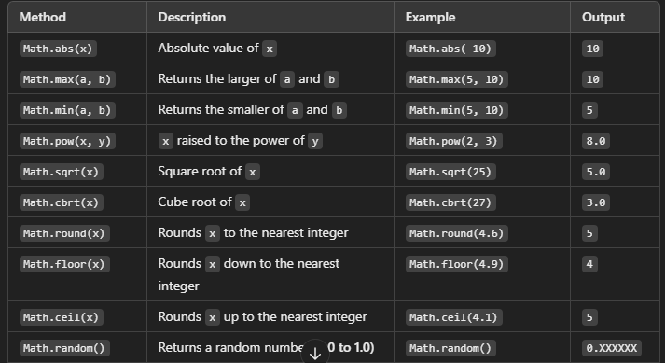

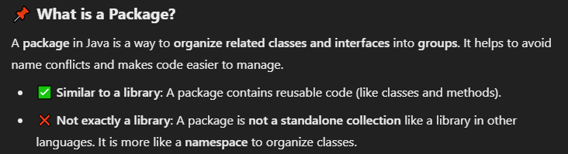

Dia 6

String class , java.lang

Un objeto inmutable no puede cambiar su valor

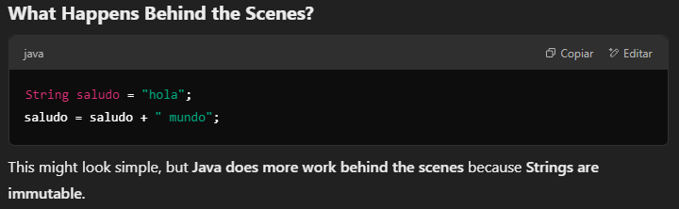

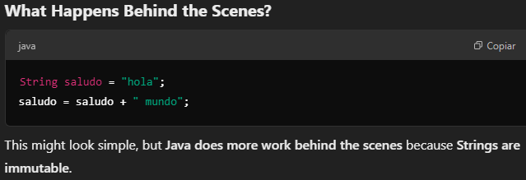

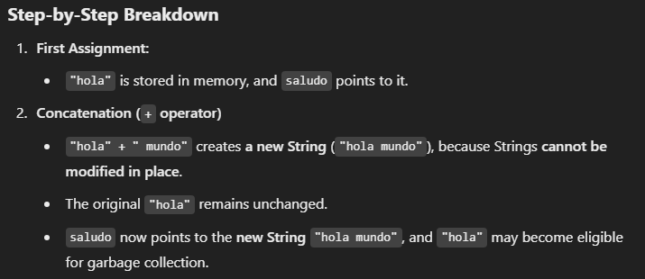

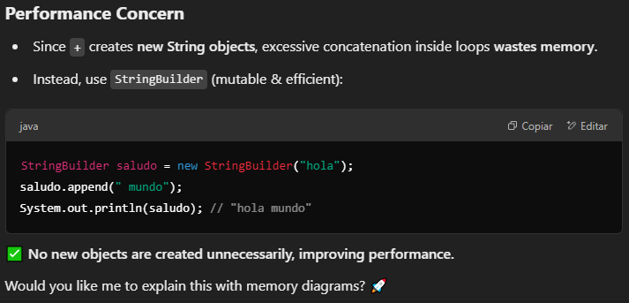

Estos son mutables





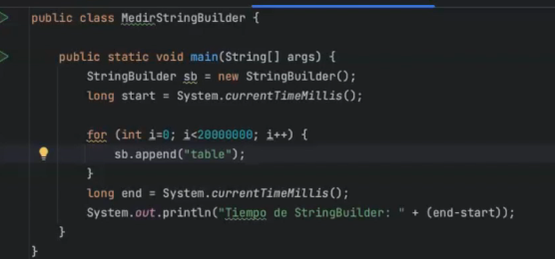

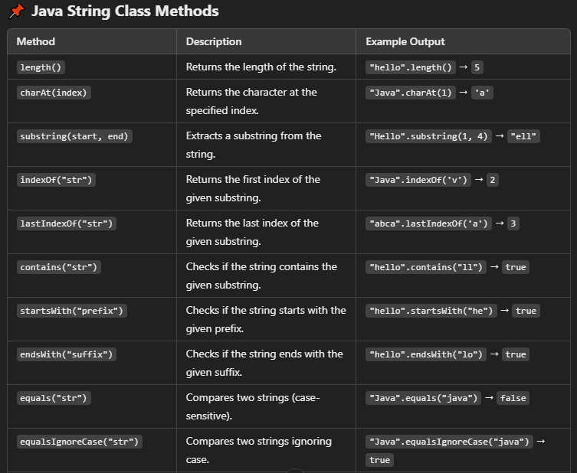

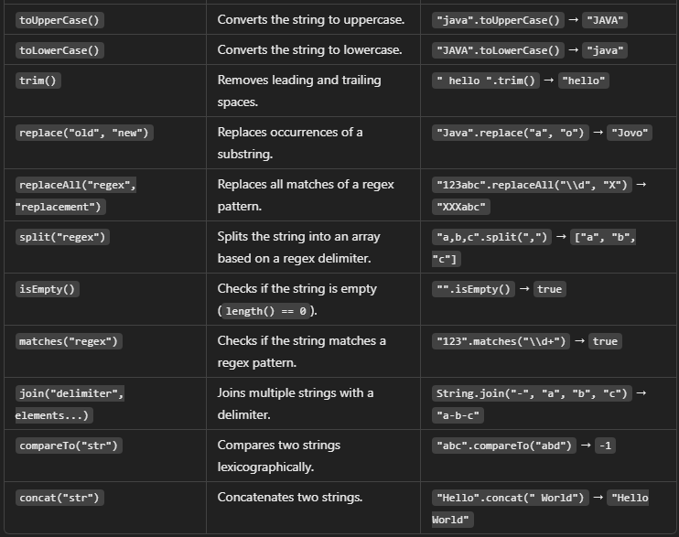

Dia 7

Final : no se puede crear objetos de esta clase

Static permite acceder al método de la clase sin que se cree un objeto de esa clase



Java lang

Modificadores de acceso

**Scanner class**

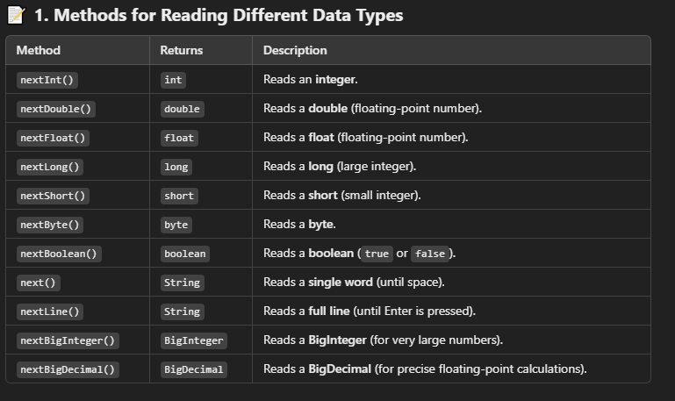

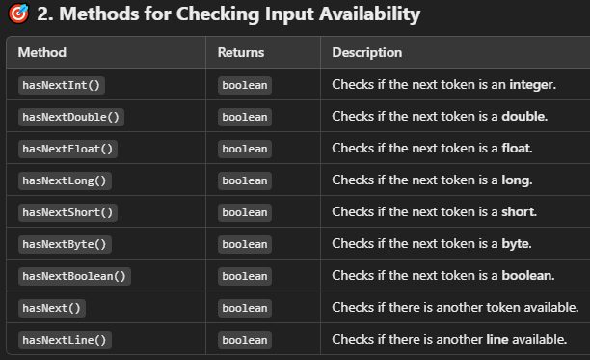

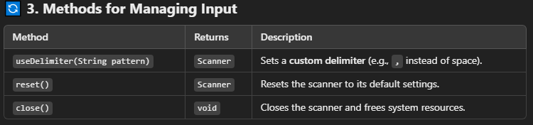

**MATH**

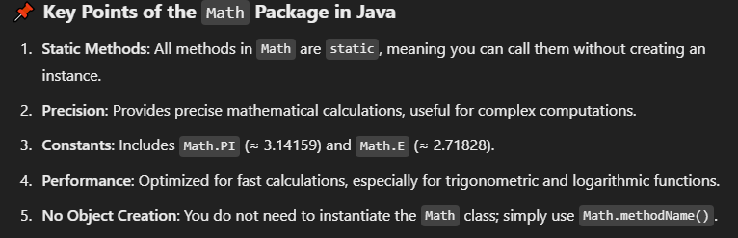

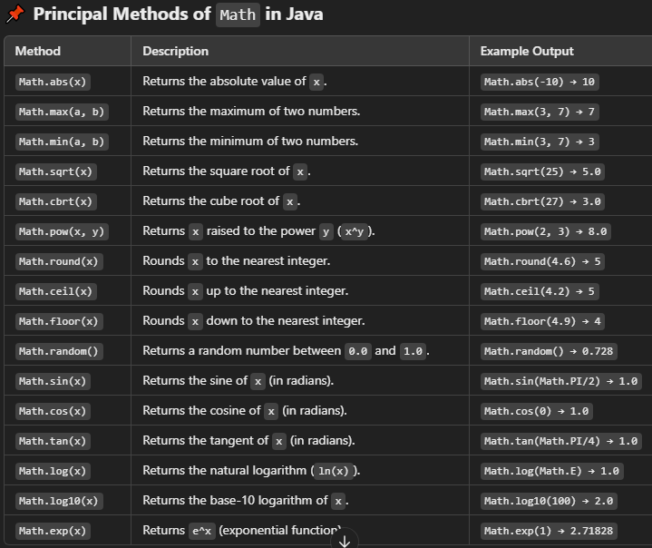

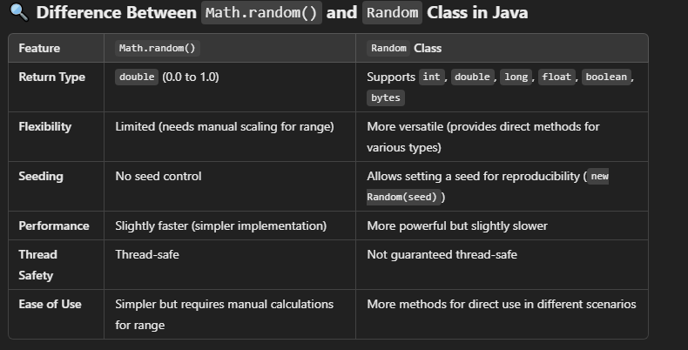

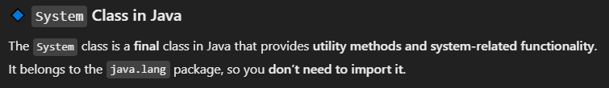

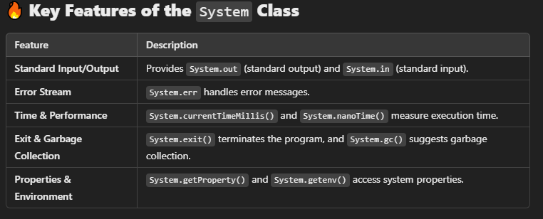

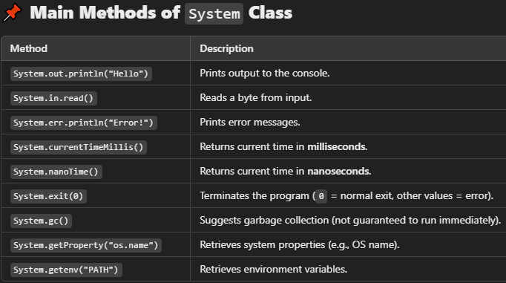

**Date**

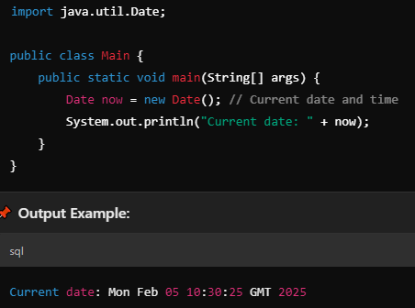

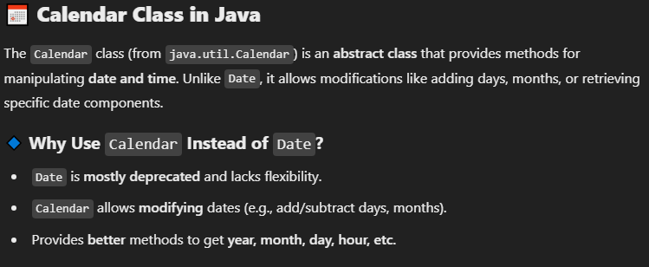

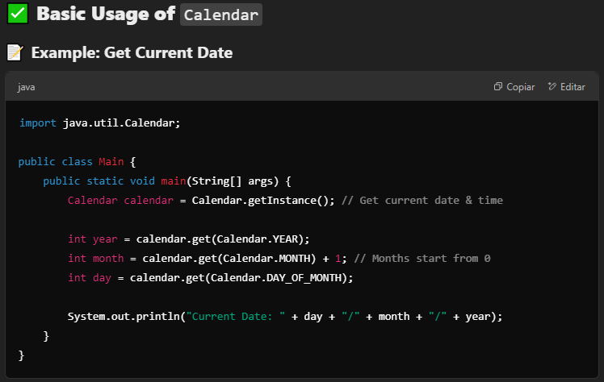

**Day 8**

**Arreglos**

Los arreglos pueden ser modificados por referencia

